RULES AND REGULATIONS OF ARNIS

The Arnis Competition will be conducted in accordance with the Arnis India Federation Rules and Regulation to ensure the safety of the student/players.

I. SCOPE
This standard shall describe the procedures, practices and proper conduct of all competitive Arnis (Full Contact) Tournaments. This standard specifies the requirements by which the conduct of all competitions shall be synchronized on the following:
A. Facilities and Equipment
B. Participants
C. Uniforms
D. Divisions (Weight Categories)
E. Conduct of the Tournament, Scoring and Penalties

II. GAME CHARACTERISTICS
Arnis A combative sport played by two individuals using padded sticks with full body protective gears in a court measuring 8.0 x 8.0 meters, in smooth and well kept surface. Players are paired / blind matched in different weight categories.

The game is played by using prescribed padded stick in delivering artistic and legal blows, strikes, thrusts, and disarming the opponent to gain scores. The winner of the match is decided by best of three rounds. Each round lasts for two minutes.

FACILITIES AND EQUIPMENT

1.0 COMPETITION AREA (Diagram 1 and 2)
Shall refer to the area by which the conduct of the competition shall be set or held including the free zone around it.
  - Dimensions.
The playing area is a square measuring 8.0 meters by 8.0 meters with a one (1) meter free zone around it, and a clear space without any obstruction up to a height of not less than 5 meters from the playing surface.
  - Lines of the Playing Area
All lines of the playing surface are 5.08 cm. (2 inches) and must be of different color from that of the floor and other lines previously drawn for other purposes.
  - Outside Lines
Four lines mark the outside line of the playing area. The free zone distance measuring one meter in each side is drawn outside of the playing area.
  - Match Lines
Two lines of 1.0 meter long and 2.0 meters apart the center marks the horizontal match line. 1.4.1 The horizontal match lines are drawn 3 meters from the outside lines.
1.4.2 The horizontal match line left is red and the opposite horizontal match line is blue
to mark the respective line of each player.
  - Referee Line
A straight line of 1.0 meter long is drawn 2.0 meters from the center of the two players.

  - Warning Lines
A broken straight line is drawn one (1) meter before the outside line to serve as a warning to the players.
1.7 Playing Surface
1.7.1 The surface must be flat and smooth and must not be elevated from the ground.
1.7.2 The playing surface must be clean and free from foreign objects that may endanger or cause injury to the players. Other surfaces must have the approval of federation.
1.8 Neutral Corner
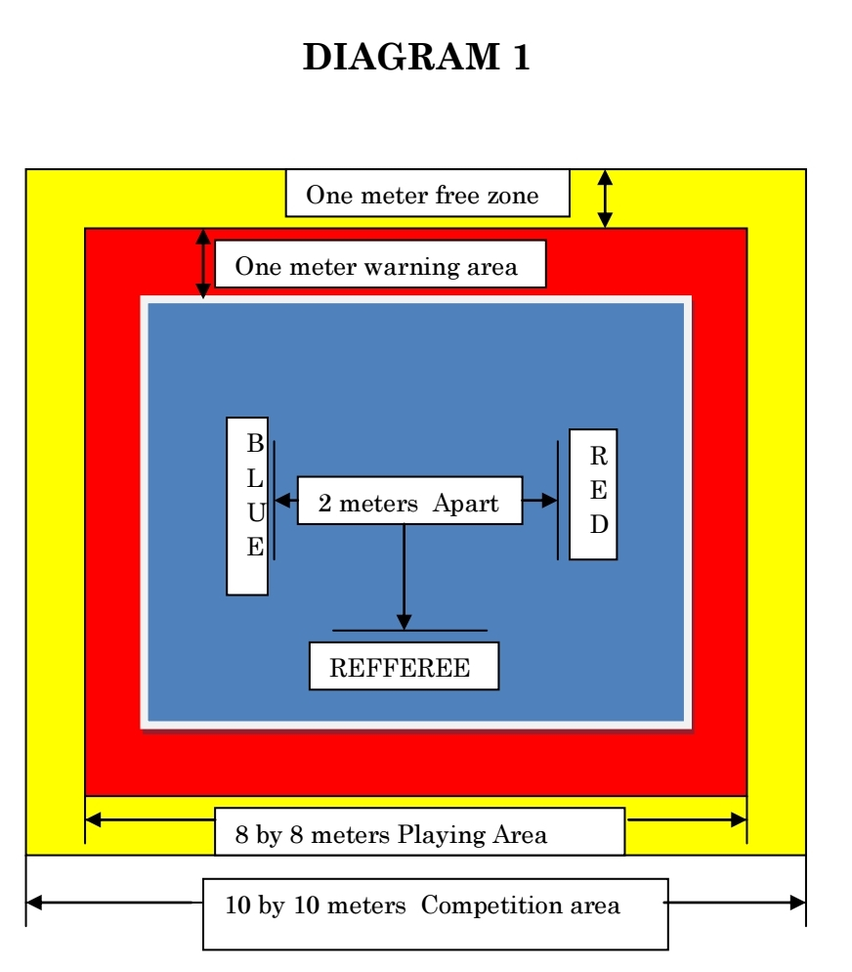
The corner of the playing area between the two (2) judges within the free zone shall be designated as the neutral corner. This shall be the consultation area for the referee and judges.
One meter free zone, One meter warning area, 2 meters Apart, REFFEREE, RED, BLUE
8 by 8 meters Playing Area, 10 by 10 meters Competition area, DIAGRAM 1.

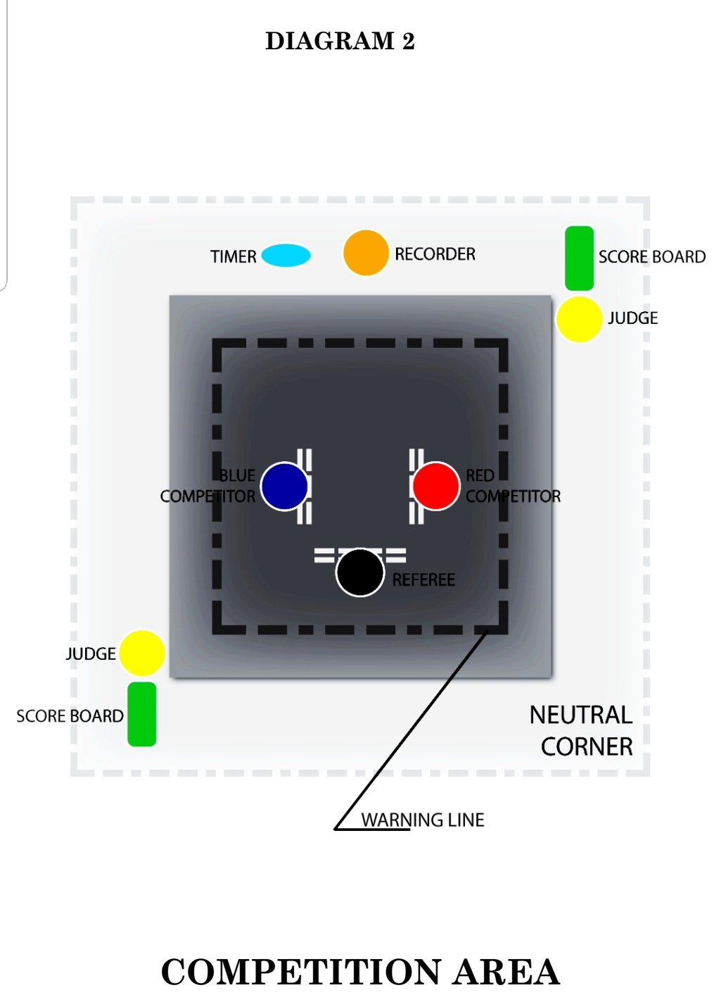
DIAGRAM 2
COMPETITION AREA
1.9 Temperature:-
The temperature for the competition shall not be higher than 30 degrees Celsius (86 degrees Fahrenheit) and not lower than 16 degrees (60.8 degrees Fahrenheit).
1.10 Lighting apparatus is located above free space (rule 1.1) it must not cause any reflection to the surface and must not affect the vision of the players. 1.11 Position of Players Before the game starts, players must be positioned in the playing area so that the red-coded player is at the right side of the referee and the blue-coded player is on his left side.

2.0 EQUIPMENT
Shall mean the materials and accessories that are used in the conduct of the competition, all of which shall conform to the standards set and approved by federation only.
2.1 Weapon
2.1.1 The padded stick shall be the official weapon of the player. The specifications of which shall be in accordance with the federation standard. No other similar material will be allowed to be used in any local, national or international competitions.
2.1.2 Each padded stick shall be properly foam-cushioned and shall have a maximum grip diameter of not more than 3.81 cm. (1 1/2 inch) and length of 76.20 cm (30 inches for men and women). The length of padded stick shall be cm (27 inches for boys and girls).
2.1.3 Both padded stick shall be color-coded, one red and the other blue.

2.2 Head Protector
2.2.1 Refers to a pair of protective head gear to include an impact-worthy face mask, the specifications of which shall be in accordance with the federation standard.
2.2.2 Both headgears must be color-coded, one red and the other blue, to match the padded stick of the player.

2.3 Body Protector
2.3.1 Refers to a pair of protective body vest, properly cushioned, the specifications of which shall be in accordance with the federation standard.
2.3.2 Male and female player must wear both body vest and groin guard. Both body vests must be color coded to match the color of the player.
2.3.3 Forearm and shin guards are compulsory. The specifications shall be in accordance with federation standard. Both shin & forearms guards must be color coded to match the color of the player.

2.4 Scoreboards (Diagram 3)
2.4.1 A pair of scoreboards, either manually or electronically operated, the specifications of which shall be in accordance with the federation standards.
2.4.2 Two score boards per contest area shall be placed at diagonally opposite corners outside the playing area, inside the competition area within the free zone, right where the judges are positioned.

2.5 Flags
2.5.1 Two sets of red and blue flags, the size of which is 30 cm by 25 cm, are used by the judges in declaring decisions or asking for consultations.
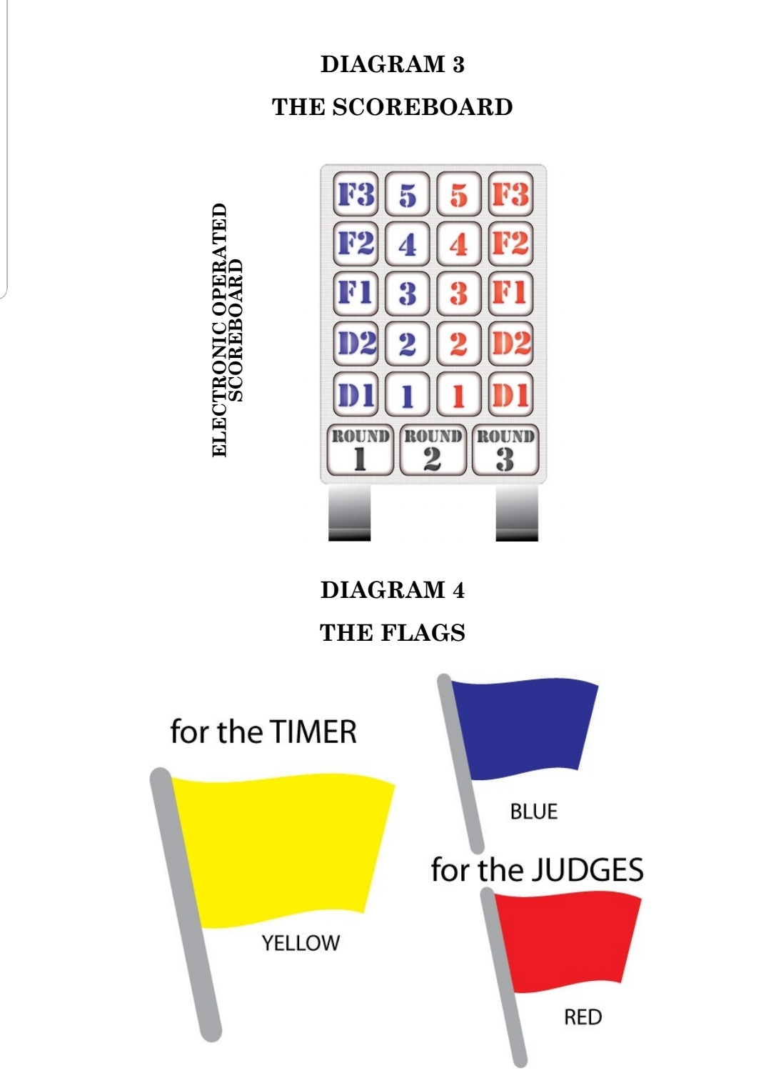

2.5.2 One yellow flag, size 30 cm by 25 cm. for timer’s use to signal the start and the end of each round and to declare a time-out and resumption of the game.

2.6 Other Equipment
2.6.1 Stopwatch is use to keep the two-minutes per round. This excludes interruptions such as injury, changing of broken padded stick. A gong and mallet or other similar audible substitutes such as whistle, bell or buzzer shall be provided for the Timer to indicate the start and end of the round.
2.6.2 A table shall be provided for the Timer and Recorder which shall be situated one (1) meter in front of the playing area so that time signals are audible enough to both players and referee.

PARTICIPANTS RULE
3.0 COMPOSITION
3.1 MEN’s & WOMEN’s team may consist of a maximum of eleven (11) players, one (1) player per weight division; one coach; one trainer; one medical doctor and two officiating RJs
3.2 BOY’S & GIRLS’ team may consist of a maximum of eleven (11) players, one (1) player per weight division; one coach; one trainer; one medical doctor and two officiating RJs.
3.3 Only players listed in the entry form shall participate in the game.

4.0 QUALIFICATIONS
Shall mean the approval by the Tournament Screening Committee for an individual or group to participate provided that the following requirements are met:
4.1 The players shall meet the requirements of the weight division in which he/she is to compete.
4.2 The players shall meet the age requirement set by the organizing committee.
4.3 The player shall be physically and mentally fit to compete as certified by a licensed medical practitioner from the player’s origin. In special cases, the official tournament physician may certify the player’s fitness. This should be submitted together with the tournament application form.
4.4 The player shall fill-up a competition application form and it should be properly and completely accomplished.
4.5 Sex test may also be required in cases where there are Doubts in real sex of the participants.
4.6 Drug test may be required in cases where there are doubts.

5.0 DUTIES AND RESPONSIBILITIES
5.1 Players 5.1.1 Players must have full knowledge of the rules of the game and are duty bound to follow.
5.1.2 Players must accept the decision of the officials with sportsmanlike conduct, without disputing them. In case of doubt, only the coach may request for clarification after the game.
5.1.3 Players must at all time observe proper decorum such as respect and courtesy towards the referee, other officials, opponent, teammates and even spectators.
5.1.4 Only members of the team who are officially listed to play are allowed to sit on the bench designated for them during the game.
5.1.5 During the game, the team members are not allowed to stand or cheer or give instructions to their member player.
5.1.6 Jeering, provocations, and similar acts which destroys spirit of competition and fair play are not allowed.
5.1.7 Any violation of the above rules shall be given corresponding penalties.
(Refer to rule 15.1)

5.2 The Coach
5.2.1 The coach is responsible for the conduct and discipline of the players. He MUST attend the solidarity meeting.
5.2.2 Coaches must at all times observe proper decorum such as respect and courtesy towards the officials, opponent, teammates and even spectators.
5.2.3 Only during time-outs and intervals between rounds may the coach give instruction, without entering the playing area or delaying the game.
5.2.4 Any violation of the above rules shall be given corresponding penalties.
(Refer to rule 15.1)
5.3 Trainer 5.3.1 if the team coach is present, the trainer may sit on the team’s bench, but has no right to intervene the match.
5.3.2 In the absence of the coach or in case the coach leaves during the match, the trainer may take over, only after properly informing the table officials who will give him authority to assume as such.
5.3.3 The trainer and other Team Officials are responsible for the conduct and discipline of their team members.
5.3.4 Any violation of the above rules shall be given corresponding penalties.
(Refer to rule 15.1)

6.0 UNIFORMS
Shall mean all those that form part of the athlete’s outfit worn in the playing area during the competition.
6.1 Clean white short sleeves T-shirt, with no extra design or accessory, except for the printed name or logo of the country or club.
6.2 Red loose pants without any lining or design.
6.3 Footwear for the competition is white shoes with rubber-sole.
6.4 Number tags shall be provided for each participant and must be attached at the backside of the T-shirt.
6.5 Wearing of accessories that may cause injury such as rings bracelets, watches, necklace, etc. are strictly not allowed.
6.6 Proper hygiene must be observed at all times. Fingernails cut short, long hair tied back, uniform clean. Spitting on the floor is not allowed.

7.0 DIVISIONS (Age & Weight Categories)
Boy’s Weight Divisions (-under16 years old) Girl’s Weight Divisions (-under16 years old):

1. Weight - over 29 up to 33 kg 1. Weight - over 29 up to 33 kg
2. Weight - over 33 up to 37 kg 2. Weight - over 33 up to 37 kg
2. Weight - over 37 up to 41 kg 3. Weight - over 37 up to 41 kg
3. Weight - over 41 up to 45 kg 3. Weight - over 41 up to 45 kg
4. Weight - over 45 up to 50 kg 4. Weight - over 45 up to 50 kg
5. Weight - over 50 up to 55 kg 5. Weight - over 50 up to 55 kg
6. Weight - over 55 up to 60 kg 6. Weight - over 55 up to 60 kg
7. Weight - over 60 up to 65 kg 7. Weight - over 60 up to 66 kg
8. Weight - over 65 and above 8. Weight - over 65 and above

Boy’s Weight Divisions (16-under18 years old) Girl’s Weight Divisions (16-under18 years old):

1. Weight - up to 47 kg 1. Weight - up to 43 kg
2. Weight -over 47 to 51 kg 2. Weight - over 43 to 47 kg
3. Weight -over 51 to 55 kg 3. Weight - over 47 to 51 kg
4. Weight - over 55 up to 60 kg 4. Weight - over 55 up to 59 kg
5. Weight - over 60 up to 65 kg 5. Weight - over 59 up to 63 kg
6. Weight - over 65 up to 70 kg 6. Weight - over 63 up to 67 kg
7. Weight - over 70 up to 75 kg 7. Weight - over 67 up to 71 kg
8. Weight - over 75 up to 80 kg 8. Weight - over 71 up to 75 kg
9. Weight - over 80 kg 7. Weight - over 75 kg

Men’s Weight Divisions (18 years and above): Women’s Weight Divisions (18 years and above):

1. Weight -blow -51 kg 1. Weight - below 47 kg
2. Weight - over 51 up to 56 kg 2. Weight - over 47 up to 50 kg
3. Weight - over 56 up to 60 kg 3. Weight - over 50 up to 54 kg
4. Weight - over 60 up to 64 kg 4. Weight - over 54 up to 58 kg
5. Weight - over 64 up to 68kg 5. Weight - over 58 up to 62 kg
6. Weight - over 68 up to 72kg 6. Weight - over 62 up to 66 kg
7. Weight - over 72 up to 76kg 7. Weight - over 66 up to 72kg
8. Weight - over 76 up to 80kg 8. Weight - over 72 up to 76kg
9. Weight - over 80 up to 85kg 9. Weight - over 76 up to 81kg
10. Weight - over 85kg 10. Weight - over 81 kg

SCORING AND PENALTIES

8.0 CONDUCT OF THE TOURNAMENT
8.1 The conduct of the competition shall be on two-out-of-three round system. Each round shall be held for a maximum of two (2) minutes.
8.2 Upon the initial command of ―Handa‖ for each round, the referee shall allow both players to display artistic Arnis movements, unique to their styles.
8.3 The player must continuously perform artistic Arnis strokes depicting their styles whenever apart during the game.

9.0 SALUTATION
At close stance, salutation is done by placing the right hand with the weapon pointing upward over the left chest, while the left arm is at the side and is followed by a Nod. Upon entering the playing area, players must do the salute to the officials together with the referee. Finally, salute must be given to the opponent. This shall be done before and after every game.

10.0 MATCHING & PAIRING
Blind matching & pairing of single elimination or knock out system shall be adopted in most cases where the number of participants will allow it. Otherwise, a round robin system shall be used. This shall be done at least one day before the tournament. Representatives from the respective teams concerned shall be invited to witness the matching & pairing.

11.0 SCORING
11.1 A score shall mean a strike or thrust with a padded stick using one hand only, delivered to a specific body point and is counted upon confirmation by the two (2) or at least one (1) of the judges, simultaneously recorded on the scoreboard.
11.2 A legitimate strike is given a point if it is delivered to a specific body point in correct form, that is –with power, right timing, with art, distance and intent.
11.2.1 Simultaneous Strike - When the two players deliver strike simultaneously, it will not be given a point.
11.2.2 Spontaneous strike is allowed, but the judges can only give maximum three (3) points per encounter per player.
11.3 A thrust to body points C and E (abdominal area and leg area) is a point, provided that the requirements for a legitimate thrust, which are with power, right timing, with art, distance (at least one arm length) and intent are met.
11.4 A disarming execution is awarded a point. (Refer to rule 16.2)
11.5 Follow-up strike after a legitimate disarming is given a point.
11.6 A score is recorded on the scoreboard by the judges.

12.0 DECLARING A WINNER OF A SPECIFIC ROUND
A player can win a round through the following manner / condition:
12.1 By gaining five points ahead.
12.2 By disarming the opponent twice.
12.3 If his opponent committed a maximum of three fouls.
12.4 Winning by knock out.
12.5 If none of these conditions are met, and the time allocated for a round had lapsed,
The winner will be based on these particular orders:
12.5.1 Who is ahead in points in general, wins. In case the two judges gave different set of
Scores, the player who has the higher points, wins.
12.5.2 In case of a tie in points, a player can win through the following manner / conditions.
12.5.2.1 One who has less disarming penalty wins.
12.5.2.2 One who has lesser fouls wins.
12.4.2.3 Disarming has a heavier weight than fouls.

13.0 DRAW SCORE
In the event that the scores, disarming and fouls are the same at the end of the round, the basis for declaring the winner shall be decided through the following:
a. superiority or aggressiveness b. major fatal technique c. artistic delivery

BODY POINTS
A. Head and Neck B. Arms and collars including hands C. Torso (from chest down to waist) D. Armpit to thigh E. leg up to knees.

PENALTIES
Players are given penalties for violations of the tournament rules and regulations.
15.1 Violation of DUTIES and RESPONSIBILITIES of players and delegation officials shall
Have the corresponding penalties. (Refer to rule 5)
15.1.1 First Offense - Player will be given a foul in a round.
15.1.2 Second Offense - Disqualification of player in the game.

BODY STRIKE POINTS
15.2 FOULS (PAGLABAG)
The following violations are considered as FOULS:
- Thrust to body point A (head area) and thrust in close quarter
(Approximately 30 inches or less).
B. Strike or thrust to the groin and Striking or thrusting using two hands.
C. Blocking with the use of the arm.
D. Clinching, spitting, negative remarks as well as other actions inimical to the rules and regulations and code of sportsmanship.
E. Pushing and Pulling— Any act of pushing and pulling using hand, head, body, legs, arm, stick a n d other similar movement.
F. A hold to an opponent. However, a hold or a grab on the padded stick or arm
G. A player who steps on the line or goes out of the playing area. However if cause by pushing using hand by the opponent is not a foul.
H. Hitting a player at the back area (from the back of the head up to the buttocks) is considered a foul, unless the opponent intentionally turns his back.
I. Delaying the game for more than ten (10) seconds.
J. Non-combativeness for ten (10) seconds.
K. Multiple strikes or thrust (three or more) to one body point without changing the position of the arm.
L. Upon the command of hinto or hiwalay, any player who attacks shall be given a foul. If the attack falls at the same time with the command, it is not considered a foul. . .
M. Non-performance of artistic styles upon the command ―handa‖ and for more than three (3) seconds during the game.
N. Diving or intentionally falling on playing surface to gain a point.
O. Food and drinks during, time out and interval of round.
P. Locking bone breaking, kicking, chopping, elbowing, throwing, punching, sweeping, butting and kneeing.
15.3 A player who commits fouls shall be given F1, F2, and F3 as the case may be and shall be indicated in the scoreboard.
15.4 A player who commits three (3) fouls is automatically declared the loser by the referee for that particular round.

16.0 DISARMING (LAGLAG)
A player who loses grip of the padded stick and a part of it touches the ground during the game is considered as disarming. However, if the padded stick was taken away in a split second by the opponent, it is counted as disarming.
16.1 A disarming violation shall be given D1 for the first disarming and one point is cut to the player who disarmed. D2 for the second disarming, and shall be indicated in the scoreboard by the judges. 16.2 A player who is disarmed twice in a round automatically loses that round.

17.0 KNOCK OUT
A disarmed padded stick used to immediately hit an opponent successfully.

18. INJURIES
When an injury occurs during the game and it cannot be continued, the decision of the judges shall be based on the following grounds:
a.) When an injured player is responsible for the injury, the other player wins.
b.) When the injury is caused by a legal blow, the injured player loses. However, when the injury is caused by an illegal blow, the injured player wins.
c.) When the responsibility of the injury cannot be determined, the judge’s decision shall be based on the score.
d.) Only the medical doctor can determine and make a decision as to the fitness of the injured player.

18.0 DISQUALIFICATION
A player is disqualified based on the following conditions.
18.1 A player who commits a dangerous intentional foul that inflicts injury or not to the other player is a ground for disqualification.
18.2 Butting, kicking, kneeing, elbowing, boxing, sweeping, chop ping, choking and other action that may inflict injury are grounds for disqualification.
18.3 Any disruptive action or behavior of the player, of his teammate and coach which break the spirit of the sportsmanship, shall mean a disqualification on the player involved.
(As per rule 15).
18.4 If for one reason or another, one of the players is disqualified, the other player shall be declared the winner.
18.5 The player/s, coach/officials or club shall be penalized by federation for all the disqualification violations.

19.0 FORFEITURE DECISION
Based on forfeiture should be forwarded to the Technical Committee. The player who forfeits his/her game during a match shall be declared the loser and will be penalized by federation.

20.0 DEFAULT
A player who does not appear at the official’s table after three (3) consecutive calls shall automatically default the game. The referee shall make the decision upon confirmation by the Technical Committee. The winner by default in this match shall enter the playing area and do the salute.

21.0 DECLARING A MATCH WINNER
21.1 A player who wins two out of three rounds wins the game.
21.2 A player wins the match if his opponent forfeits or defaults the game.
21.3 A player wins the match if his opponent was disqualified in the game.

22.0 TIME-OUTS
Only the referee may stop the time for the following reasons:
a.)Giving fouls b.)Injury occurs c.)Declaring winners d.)Disarming is executed e.)Judges request for timeouts f.) Consultation with judge’s g.)Fixing or changing of uniform, broken equipment such as headgear, padded stick, etc. H.)End of each round

23.0 PROTESTS
23.1 Any protests must be made in writing by the COACH addressed to the Technical Committee and forwarded within five minutes after the game to the official’s table. Any action made otherwise shall be nullified. A bond shall be set for protest (refer to technical committee).
23.2 A solidarity meeting shall be set before the tournament. The coach who has not attended the solidarity meeting shall waive all his rights to protest. (Refer to rule 5.2.1)
23.3 JUDGEMENT CALL cannot be protested.

PART II ARNIS ANYO EVENT

I. SCOPE This standard shall describe the procedures, practices and proper conduct of all Arnis Anyo Competition. This standard specifies the requirements by which the conduct of all ANYO competitions shall be synchronized on the following:
II. GAME CHARACTERISTICS Arnis Anyo (form) event is a demonstration of artistic, choreographed, pre-arranged sets of movements, offensive and defensive techniques using stick, wooden replica of a bladed weapon or metallic un bladed replica of a weapon. The competition shall be one round of Anyo performance, where in the performers are awarded points by the judges based on criteria. The performance shall have a minimum time limit of one (1) minute and a maximum time limit of two (2) minutes. There would be different divisions in the single weapon, double weapon and sword & dagger weapon categories, both in the individual and team events. The players will be ranked based on the scores awarded by the judges.
A. Facilities and Equipment B. Participants C. Divisions (Age Categories) D. Rules of the Game

FACILITIES AND EQUIPMENT

1.0 COMPETITION AREA Shall refer to the area by which the conduct of the competition shall be set or held including the free zone around it.(12 meters by 12meters) in size.
1.1 Dimensions
The playing area is a square measuring 10 meters by 10 meters with a one meter minimum free zone around it, and a clear space without any obstruction up to a height of not less than 5 meters from the playing surface.
1.2 Lines of the Playing Area
All lines of the playing surface are 5.08 cm. (2 inches) and must be of a different color from that of the floor and other lines previously drawn for other purposes.
1.3 Outside Lines
Four lines mark the outside line of the playing area. The free zone distance measuring one meter are drawn outside of the playing area.
1.4 Entry Lines
The entry line is the farthest line parallel to the position of the judges.
1.5 Playing Surface
1.5.1 The surface must be flat and smooth and must not be elevated from the ground.
1.5.2 The playing surface must be clean and free from foreign objects that may endanger or cause injury to the players. Other surfaces must have the approval of federation
1.6 Temperature
The minimum temperature for an outdoor competition shall not be below 25 degrees Celsius (77 Fahrenheit). For the indoor competition, the temperature shall not be higher than 25 degrees Celsius (77 Fahrenheit) and lower than 16 degrees Celsius (61 Fahrenheit).

  - Lighting:
Lighting apparatus is located above the free space; it must not cause any reflection to the surface and must not affect the vision of the performer/s.
1.8 Entrance of Players before the game starts, players must enter thru the entry lines.

2.0 EQUIPMENT
Shall mean the materials and accessories that are used in the conduct of the competition.
2.1 Weapon
Players are required to use any of the following options.
2.1.1 Wooden Stick the wooden stick shall measure not less than 60 cm and not more than 90 cm in length with a diameter of not less than 1.3 cm and not more than 3.8 cm. It must not have sharp edges or pointed ends.
2.1.2 Wooden Replica of a Bladed Weapon the wooden replica shall measure not less than 60 cm and not more than 90 cm in full length and should be Ethnic Asian in origin. It must not have sharp edges or pointed ends.
2.1.3 Metallic Blunt Replica of a Bladed Weapon the metallic replica shall measure not less than 60 cm and not more than 90 cm in full length and should be ethnic Asian in origin. It must not have sharp edges or pointed ends.
2.1.4 Wooden Replica of a Dagger or Knife the wooden replica shall measure not more than 60 cm in full length and should be ethnic Asian in origin. It must not have sharp edges or pointed ends.
2.2 Score Card
Judges will use score card to indicate the score given to a player or a team. The score card shall measure 12 x 8 inches (30.48 cm x 20.32 cm). .
2.3 Tabulation Sheet
The scores and violations shall be reflected on the Tabulation Sheet.
2.4 Flags
2.4.1 Yellow flag shall be used by the timer to declare the start and the end of performance. 2.4.2 Blue flag shall be raised by the official to indicate loses control of the weapon/s.
2.4.3 Red flag shall be raised by the official to indicate stepping outside of the playing area.
2.4.4 Both flags shall be raised by the official to indicate violation of standard salutation simultaneously whistling to call the attention of the performer/s.
2.5 Other Equipments
2.5.1 Stop clock or stopwatch to keep track of the time of the performance.
2.5.2 A gong and mallet or other similar audible substitutes such as whistle, bell or buzzer shall be provided for the timer to indicate the start and end of the performance.

PARTICIPANTS
3.0 COMPOSITION
A team may consist of a maximum total of twenty four (24) players, (composed of twelve (12) male players and twelve (12) female players); one coach, one trainer, one medical doctor, and two officiating judges licensed by federation.
3.1 Individual Event
A team may field in one player per category. Only players listed in the entry form may participate in the competition.
3.1.1 Single Weapon Category
3.1.2 Double Weapon Category
3.1.3 Sword and Dagger Category

3.2 Team Event (Synchronized Anyo)
A team shall compose of three (3) performers per category. Only players listed in the entry form shall participate in the competition.
3.2.1 Single Weapon Category
3.2.2 Double Weapon Category
3.2.3 Sword and Dagger Category

4.0 QUALIFICATIONS
Shall mean the approval by the Tournament Screening Committee for an individual or team to participate, provided that the following requirements are met:
4.1 The player shall meet the age requirement set by the organizing committee on a specific category.
4.2 The player shall be physically and mentally fit to compete, as certified by a licensed medical practitioner from the applicant’s origin. In special cases, the official tournament physician may certify the player’s fitness. This should be submitted together with the competition form.
4.3 The player shall fill-up a competition form, and it should be properly and completely accomplished.
4.4 Sex test may also be required in cases where there are doubts in real sex of the player. 4.5 Drug test may also be required in cases where there are doubts.

5.0 DUTIES AND RESPONSIBILITIES
5.1 Players 5.1.1 Players must have full knowledge of the rules of the game and are duty bound to follow.
5.1.2 Players must accept the decision of the officials with sportsmanlike conduct, without disputing them. In case of doubt, only the coach may request for clarification after the match.
5.1.3 Players must at all time observe proper decorum as respect and courtesy towards the officials, opponent, teammates and even spectators.
5.1.4 Jeering, provocations, and similar acts which destroys spirit of sportsmanship and fair play are not allowed.
5.1.5 Only members of the team who are officially listed to perform/s are allowed to sit on the bench during the competition.
5.1.6 Any violation of the above rules shall be given corresponding penalties. (Refer to rule 12)

5.2 The Coach
5.2.1 The coach is responsible for the conduct and discipline of the players. He MUST attend the solidarity meeting.
5.2.2 Coaches must at all times observe proper decorum such as respect and courtesy towards the officials, opponent, teammates and even spectators.
5.2.3 During the performance, he/ she must stay at the area designated for him / her.
5.2.4 Any violation of the above rules shall be given corresponding penalties. (Refer to rule 12)

5.3 Trainer
5.3.1 If the team coach is present, the trainer may sit on the team's bench but has no right to intervene the competition.
5.3.2 In the absence of the coach or in case the coach leaves during the match, the trainer may take over, only after properly informing the table officials who will give him authority to assume as such.
5.3.3 The trainer and other Team Officials are responsible for the conduct and discipline of their team members.
5.3.4 Any violation of the above rules shall be given corresponding penalties. (Refer to rule 12)

6.0 DIVISIONS
6.1 MEN & WOMEN’S DIVISION (18 years old & above)
6.1.1 Individual Event
A. Single Weapon Category
B. Double Identical Weapon Category
C. Sword & Dagger Category
6.1.2 Team Event
A. Single Weapon Category. B. Double Identical Weapon Category. C. Sword & Dagger Category.

6.2 BOYS & GIRLS’ DIVISION (12-17 years old)
6.2.1 Individual Event
A. Single Weapon Category B. Double Identical Weapon Category. C. Sword & Dagger Category
6.2.2 Team Event
A. Single Weapon Category. B. Double Identical Weapon Category C. Sword & Dagger Category

6.3 CHILDREN’S DIVISION (Boys and Girls ages 7-11 years old)
6.3.1 Individual Event
A. Single Weapon Category B. Double Identical Weapon Category C. Sword & Dagger Category

6.3.2 Team Event
A. Single Weapon Category. B. Double Identical Weapon Category. C. Sword & Dagger Category
CONDUCT OF THE TOURNAMENT, SCORING AND PENALTIES

7.0 CONDUCT OF THE TOURNAMENT The conduct of the competition shall be one Anyo performance. The performance shall have a minimum time limit of one (1) minute and a maximum time limit of two (2) minutes.
8.0 SALUTATION
8.1 Single Weapon Category At close stance, salutation is done by placing the right hand with the weapon pointing upward over the left chest, while the left arm is at the side and is followed by a Nod. Upon entering the competition area, players must do the salute to the officials. This shall be done before and after every performance.
8.2 Double Weapon Category at close stance, salutation is done by placing the right hand with the weapon over the left chest, while the simultaneously extending the left hand with the other weapon horizontally to his/ her left side with both weapons pointing upward and is followed by a Nod. Upon entering the competition area, players must do the salute to the officials. This shall be done before and after every performance.

9.0 ORDER OF COMPETITION
The order of competition shall be made through drawing of lots. This shall be done at least a day before the competition. Representatives from respective teams concerned shall be invited to witness the drawing of lots.

10.0 SCORING
10.1 A score shall be awarded by the judges to the performer/s and shall be reflected on the score card raised above their heads.
10.2 A score shall have a numerical value from 1-10 with an increment of 0.25.
10.3 The seven Judges shall formulate their judgment and scoring base on the specified criteria.

11.0 CRITERIA
11.1 Coordination of Movements (Individual Event)
Harmonizing and dexterity of the movements of arms, legs, head, body and weapons of the performers. Well balanced actions, steps, stance and movements (sense of balance). Precise timing, indistinguishable, identical harmonic and rhythmic movements of the arms, head, legs, body, and weapons of the performer during the performance.

11.2 Synchronization (Team Event)
Harmonizing and dexterity of the movements of arms, legs, head, body and weapons of the performers. Well balanced actions, steps, stance and movements (sense of balance). Precise timing, indistinguishable, identical harmonic and rhythmic movements of the arms, head, legs, body, and weapons of the team during the performance.

11.3 Artistic
Execution Graceful, elegant, refined, stylish and animated execution of the martial arts movements of the performer/s.

11.4 Bearing and Stage Presence
11.4.1 Manner, composure, costume, poise and posture of the performer/s during the performance.
11.4.2 Costume shall mean all those that form part of the athlete's attire worn in the competition area during the tournament. It should be ethnic Asian in origin.
11.4.3 Musical Accompaniment (optional) the player or team may or may not choose to have a musical accompaniment with their performance. Should they opt to have musical accompaniment, it should be ethnic Asian in nature, live or recorded on CD or USB.

11.5 Degree of Difficulty
the magnitude of complicatedness, complexity, intricacy of the movements of the arms, body and legs in executing martial arts techniques of the whole performance.

11.6 Creativity Originality, inventiveness and imaginativeness of the forms and movements without sacrificing the effectiveness of the martial art movements.

12.0 DRAW SCORE
In the event that the scores are the same, the basis of declaring the winner shall be decided through the following:
12.1 Remove highest and lowest scores of the players/teams concerned given by the 7 or 5 judges.
12.2 In case there is still a draw, remove the highest and lowest scores of the players/teams concerned given by the remaining 5 or 3 judges.
12.3 In case there is still a draw, a repeat performance shall be done by the remaining players/teams that have the highest and the same scores. Note: This shall be applied only for the first, second and third placers. Players are also given penalties for violations of the competition rules and regulations.

13.0 DECLARING A WINNER
The player/team garnering the highest score-First Place, second highest score– Second Place, and third highest score-Third Place.

14.0 PENALTIES
Players are given penalties for violations of the competition rules and regulations. All deductions are being taken from the total scores of all the judges.
14.1 Violation of Standard Salutation shall cause the performer/s deductions of five (5) points per violation and per player in a team.
14.2 Violation of Time Limit shall cause the performer/s deductions of two (2) points in short of the minimum one (1) minute time limit or in excess of the maximum two (2) minute time limit.
14.3 Stepping or going outside of the playing area will cause the performers a deduction of two (2) points. Per violations and per players in a team.
14.4 A Performer/s who loses control of the weapon/s shall be given a deduction of five (5) points per violation.
14.5 Weapon gets destroyed or has any apparent damage to any part of the weapon will cause the performers a deduction of five (5) points per violation and per player in a team.

15.0 DISQUALIFICATION
15.1 Any disruptive action or behavior of the performer/s and or his teammates, coach/officials, which breaks the spirit of the sportsmanship, shall mean a disqualification. 1
5.2 Submission of fraudulent or falsified documents shall mean a disqualification on the player / team involved.

16.0 FORFEITURE
Decisions based on forfeiture should be forwarded to the technical committee. The performer / team who forfeits the game automatically looses in that particular event.

17.0 DEFAULT
A performer / team who does not appear/s to the officials table after three (3) consecutive calls shall automatically default the game. The officials shall make the decisions upon confirmation by the Technical Committee.

18.0 PROTESTS
18.1 Any protests must be made in writing by the COACH addressed to the Technical Committee and forwarded within five minutes after the game to the official’s table. Any action made otherwise shall be nullified. A bond shall be set for protest (refer to technical committee).
18.2 A solidarity meeting shall be set before the tournament. The coach who has not attended the solidarity meeting shall waive all his rights to protest. (Refer to rule 5.2.1)
18.3 JUDGES SCORES cannot be protested.

Part III -TOURNAMENT OFFICIALS - DUTIES AND RESPON SIBILITIES

HAND SIGNALS AND CALLS
- Tournament Officials
the official body who shall implement the rules and regulations and shall have the sole authority in the administration of the tournament proper. The tournament officials are certified by the federation.

1.1 Tournament Director
The overall administrator and chairperson who shall directly ensure the proper implementation of all procedures.

1.2 Screening Committee
This committee is composed of three (3) members who shall enforce the requirements as stipulated in Rule 4, Chapter Two. This committee shall include the Tournament officials and a Physician as members.

1.3 Referees and Judges
These are officials who enforce the conduct of all tournament in accordance with the rules and regulations of the game. All Referees & Judges should have taken and passed the accreditation and licensure seminar of federation and must be in good standing. Refreshers Course is required for all Referees and Judges who have not officiated in any tournament for at least one (1) year. They are the officiating officials of the tournament whose decisions are FINAL.

1.4 Timer
Shall keep time during the actual match is going, whistle or bell shall be provided for his/her use in announcing the start and the end of the game and other calls.
1.5 Recorder
Shall be tasked with recording the results of the actual games. A record sheet shall be provided for his/her use in recording results.
1.6 Tabulators
Shall compose of the Chairman of the Judges, Recorder and Timer. They shall be tasked in recording the scores, violations, and the time of the actual performance/s. They shall give the final results to the official’s table.
1.7 Flag Officials
These are the officials who will declare the violation/s of the performer/s by raising the corresponding flag/s.
1.8 Matcher shall arrange the matches prior to the tournament and update the matches between players during the tournament.

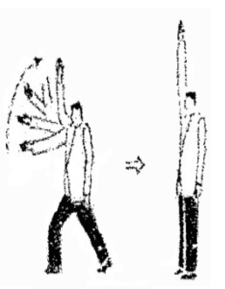
RULE 2.0
OFFICIAL CALLS AND HAND SIGNALS
(FULL CONTACT EVENT)
2.1 H A N D A, L A B A N
(Ready, Start) Hand with thumb up, placed between
the two players and simultaneously drawn upward.

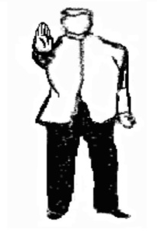
2.2 H I N T O
(Stop) is said with the stop sign outstretched arm forward, palm facing
front with fingers pointing upward, to stop a fight or call for timeout.

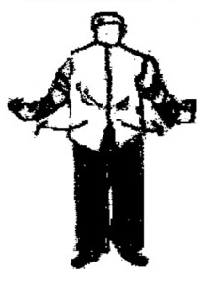
2.3 H I W A L A Y
(Separate / Break) Arms are extended forward, then spread out laterally,
Simultaneously saying the command. Done in instances when the competitors
are in close body contact after a period of 3 seconds, provided that there is no
foul committed.
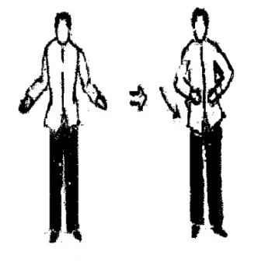

2.4 P A Y O
(Consultation with the judges)- From out-stretched arms,
bring both arms a bit close together at hip level. The referee
turns around to face and point to the neutral corner signaling
the judges for a consultation.
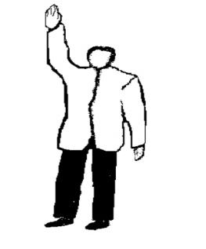

2.5 H A T O L
(Decision) - Right arm raised above the head with palm facing the left.

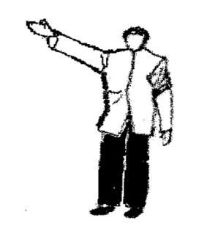
2.6 P A N A L O
(Declaring the Winner)-One arm is raised obliquely at approximately
45 degrees to the direction of the winning contestant from the chest.
Right arm for the red and left arm for the blue player.

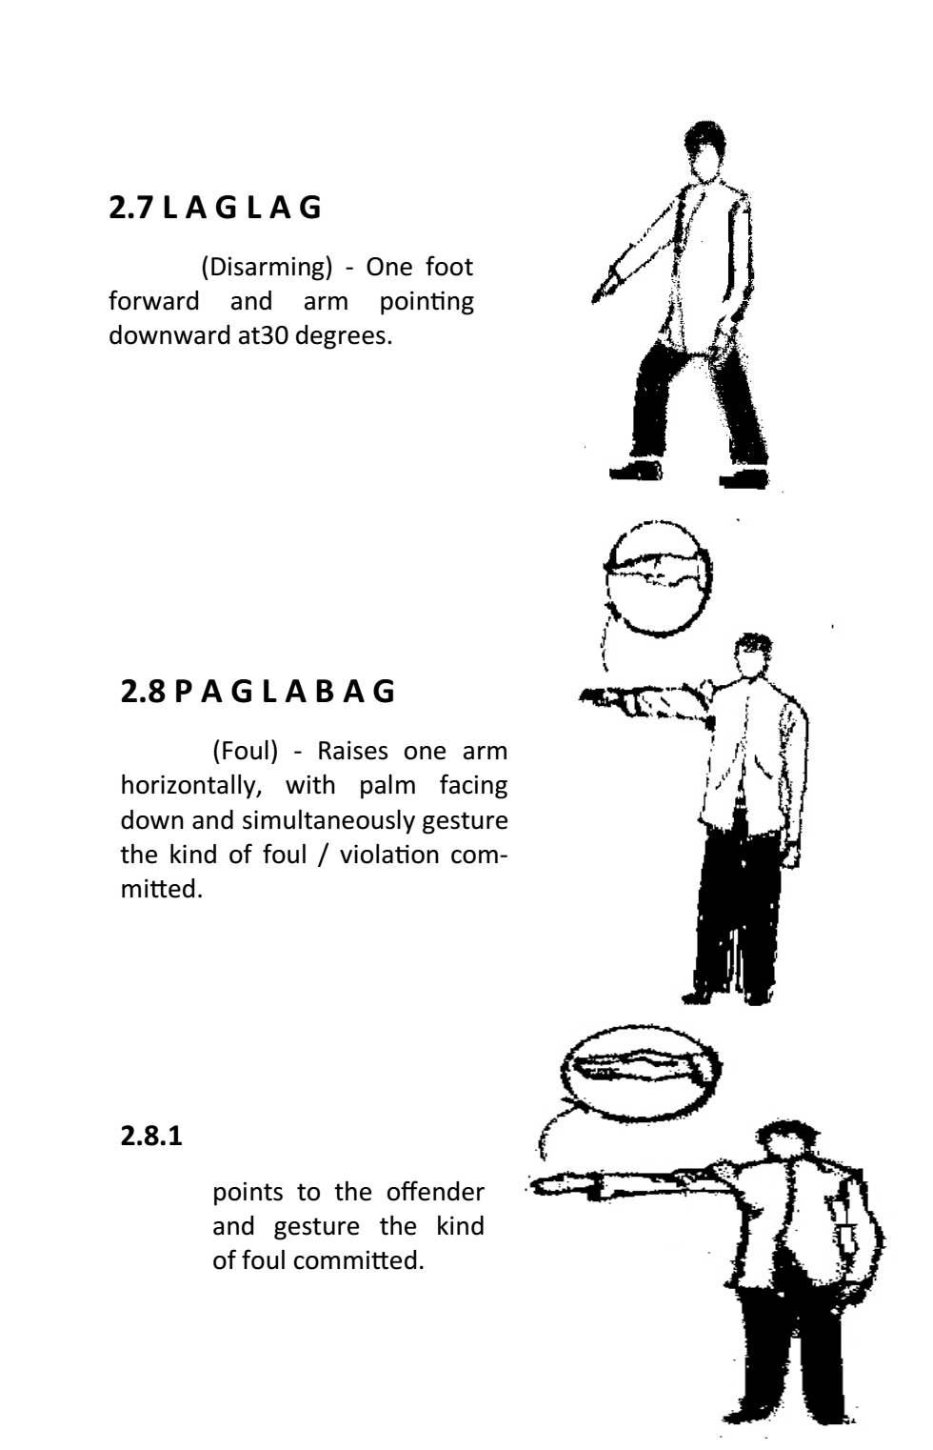

2.7 L A G L A G
(Disarming) - One foot forward and arm pointing downward at30 degrees.

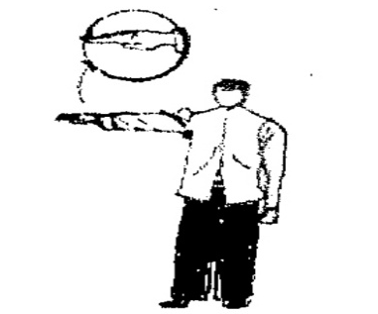
2.8 P A G L A B A G
(Foul) - Raises one arm horizontally, with palm facing down and
simultaneously gesture the kind of foul / violation committed.

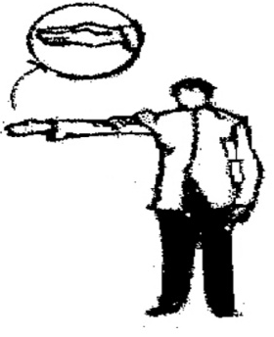

2.8.1
Points to the offender and gesture the kind of foul committed.

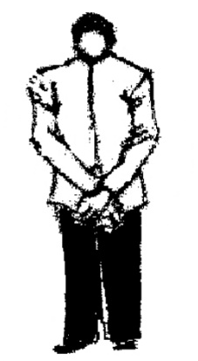

2.9 M A G - A Y O S
(Adjusting or Fixing) - Both arms are crossed over in front with palms
facing in at waist level.

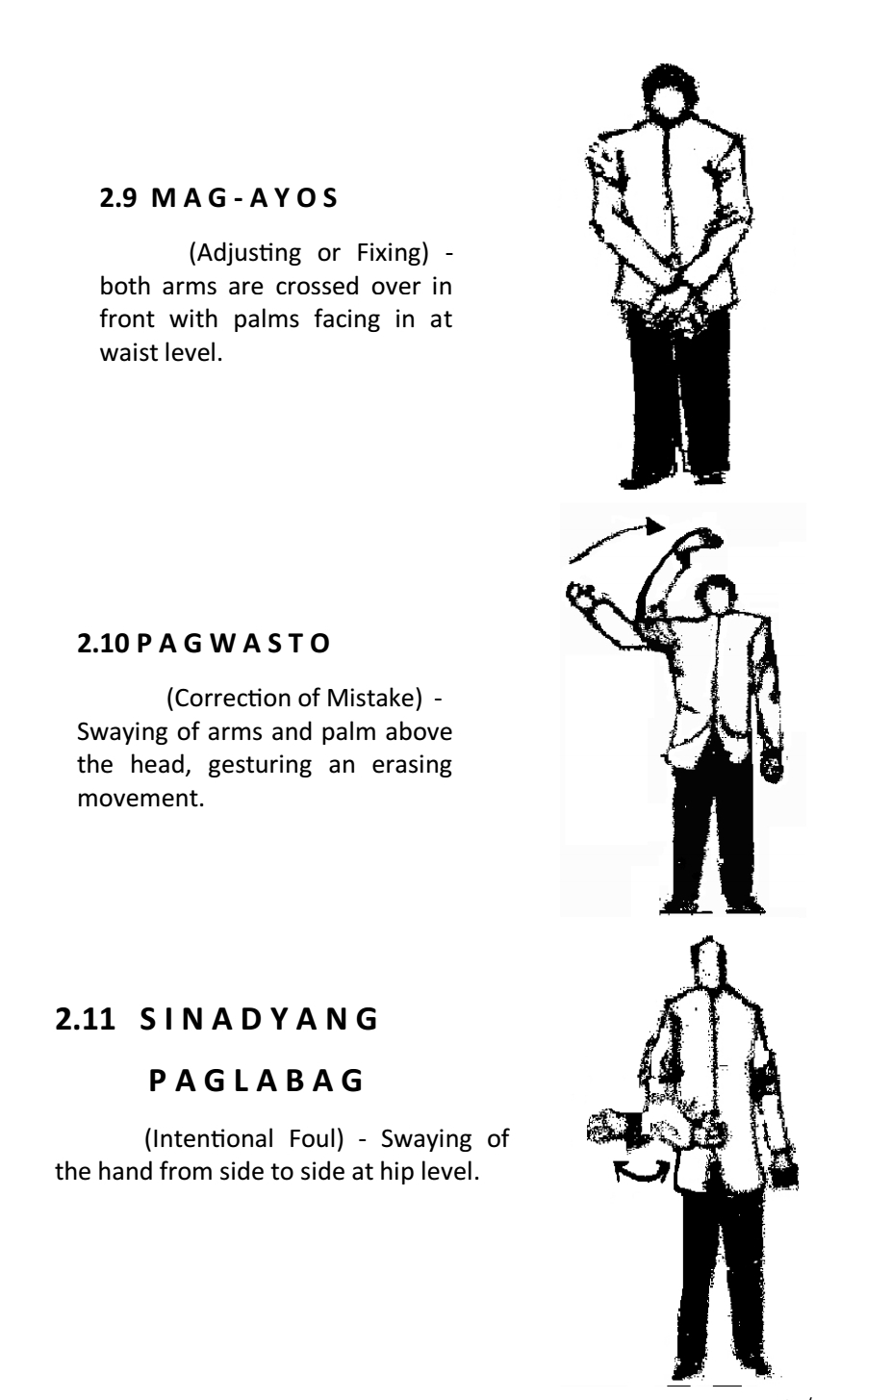

2.10 P A G W A S T O
(Correction of Mistake) - Swaying of arms and palm above the head,
gesturing an erasing movement.

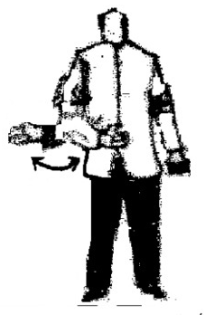

2.11 S I N A D Y A N G
P A G L A B A G
(Intentional Foul) - Swaying of the hand from side to side at hip level.

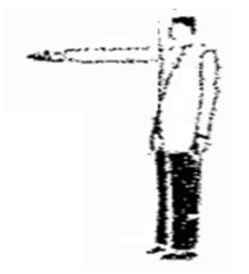

2.11.1 PARUSA (Penalty)
Going in front of the offender and simultaneously pointing him/her.
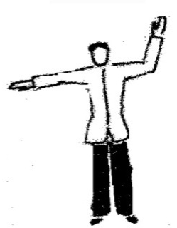

2.12 PI N S A L A
(Injury) - one arm raised above the head and the other arm raised
horizontally at shoulder level, palm facing down.

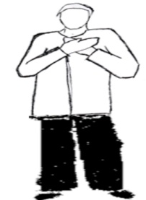

2.13 M ALING GAWI
(Wrong Action) - Both arms are crossed in front of the chest,
palms facing in.

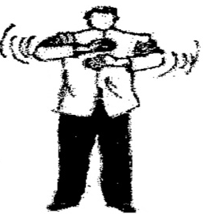

2.14 WALANG L A B A N A N
(Non-Combativeness) - circling of both forearms back
and forth with hand closed.

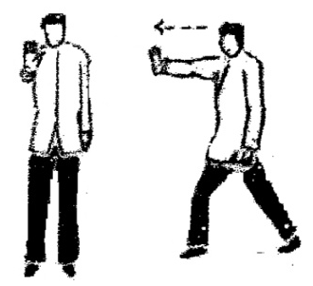

2.15 P A G T U L A K
(Pushing) - right arm gestures an outward pushing.

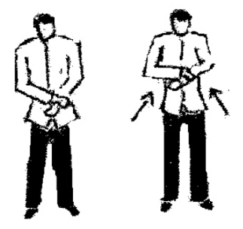

2.16 P A G H A W A K
(Grabbing) - Grab left wrist with right hand.

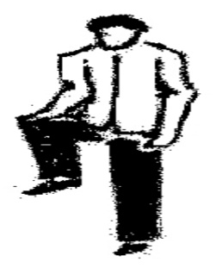

2.17 P A G T U H O D
(Kneeing) - lift one knee up simultaneously tapping the knee.

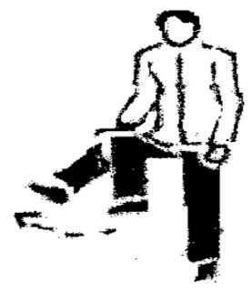

2.18 PAGSIPA
(Kicking) - lift one knee up simultaneously extending the foot
forward that gestures the act of kicking.
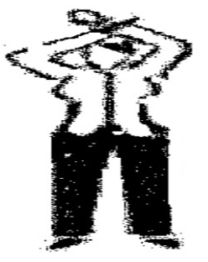
2.19 P A G S A L A G
(Blocking with the use of the arm) - lift left arms overhead to
block the right arm from hitting the head.

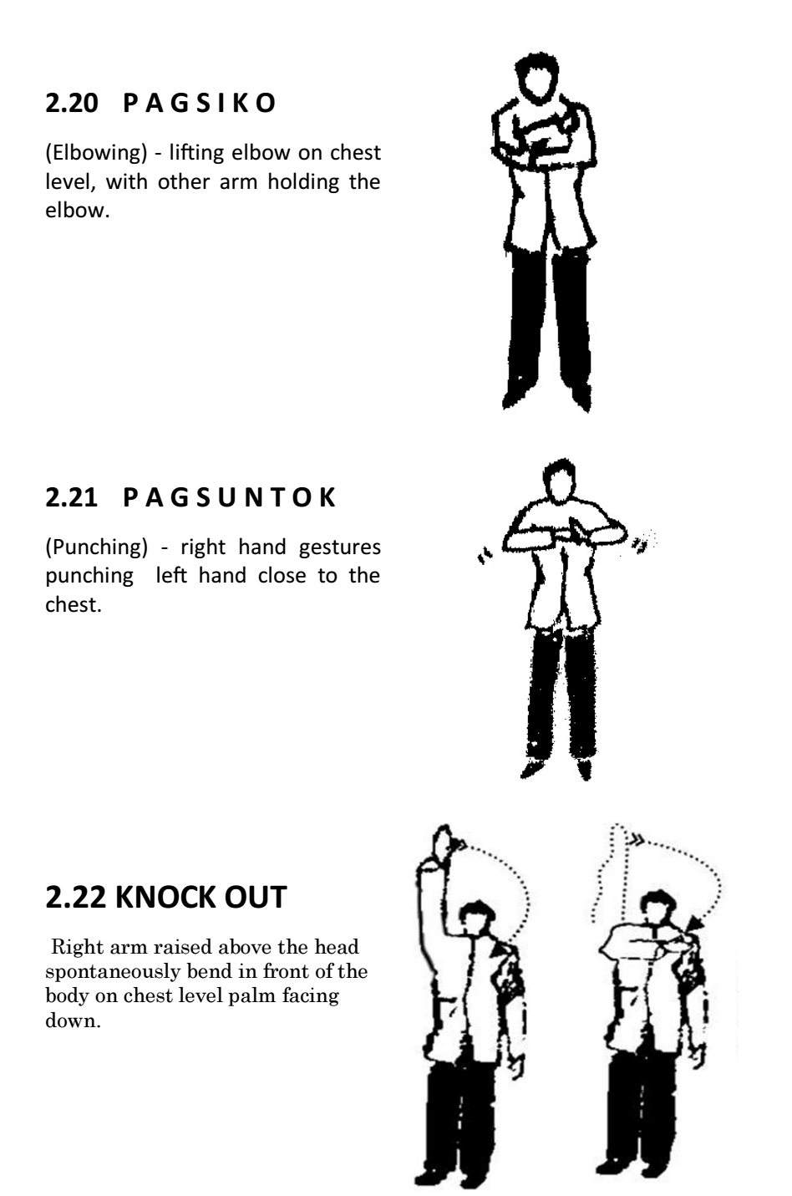

2.20 P A G S I K O
(Elbowing) - lifting elbow on chest level, with other arm holding the elbow.

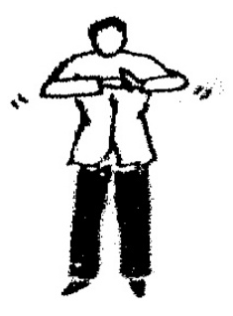

2.21 P A G S U N T O K
(Punching) - Right hand gestures punching left hand close to the chest.

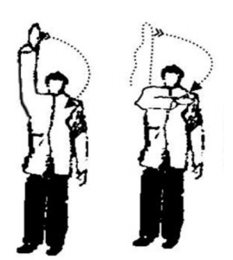

2.22 KNOCK OUT Right arm raised above the head spontaneously
bend in front of the body on chest level palm facing down.

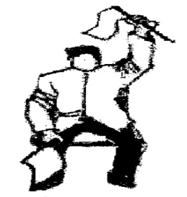
JUDGES SIGNALS

2.23 DECLARING A WINNER
Raises the flag whose color corresponds to the winning
Player above the head.
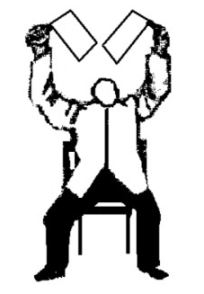

2.24 DECLARING A DRAW
Raises both flags above the head.

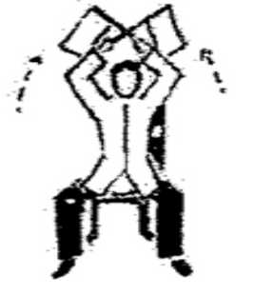

2.24 P A Y O
CONSULTATION/ REQUESTING
for TIME – OUT Crosses the flags above the head.

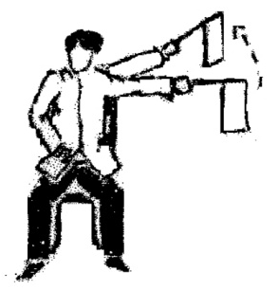

2.25 L A B A S (Outside) - left to right swaying of the flag
parallel to the line of the playing area concerned using the
color of the player.
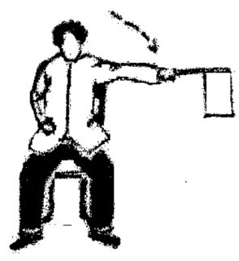

2.26 LOOB (Inside) - a flag parallel to the line of the area
concerned using the color of the player.

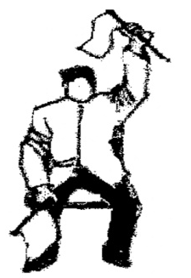
RULE 3.0
OFFICIAL CALLS AND HAND SIGNALS
FOR ANYO EVENT
3.2 Declaring a Violation
the flag official shall raise the flag/s above their heads per
violation committed, the Recorder is responsible in recording
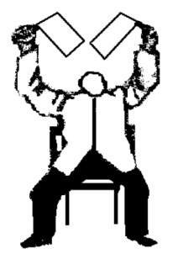
the penalties/ deduction raised by the flag officials .

3.3 Violation of Standard
Salutation
The flag officials shall call the attention of the performer/s
by blowing the whistle and raising the two flags above their
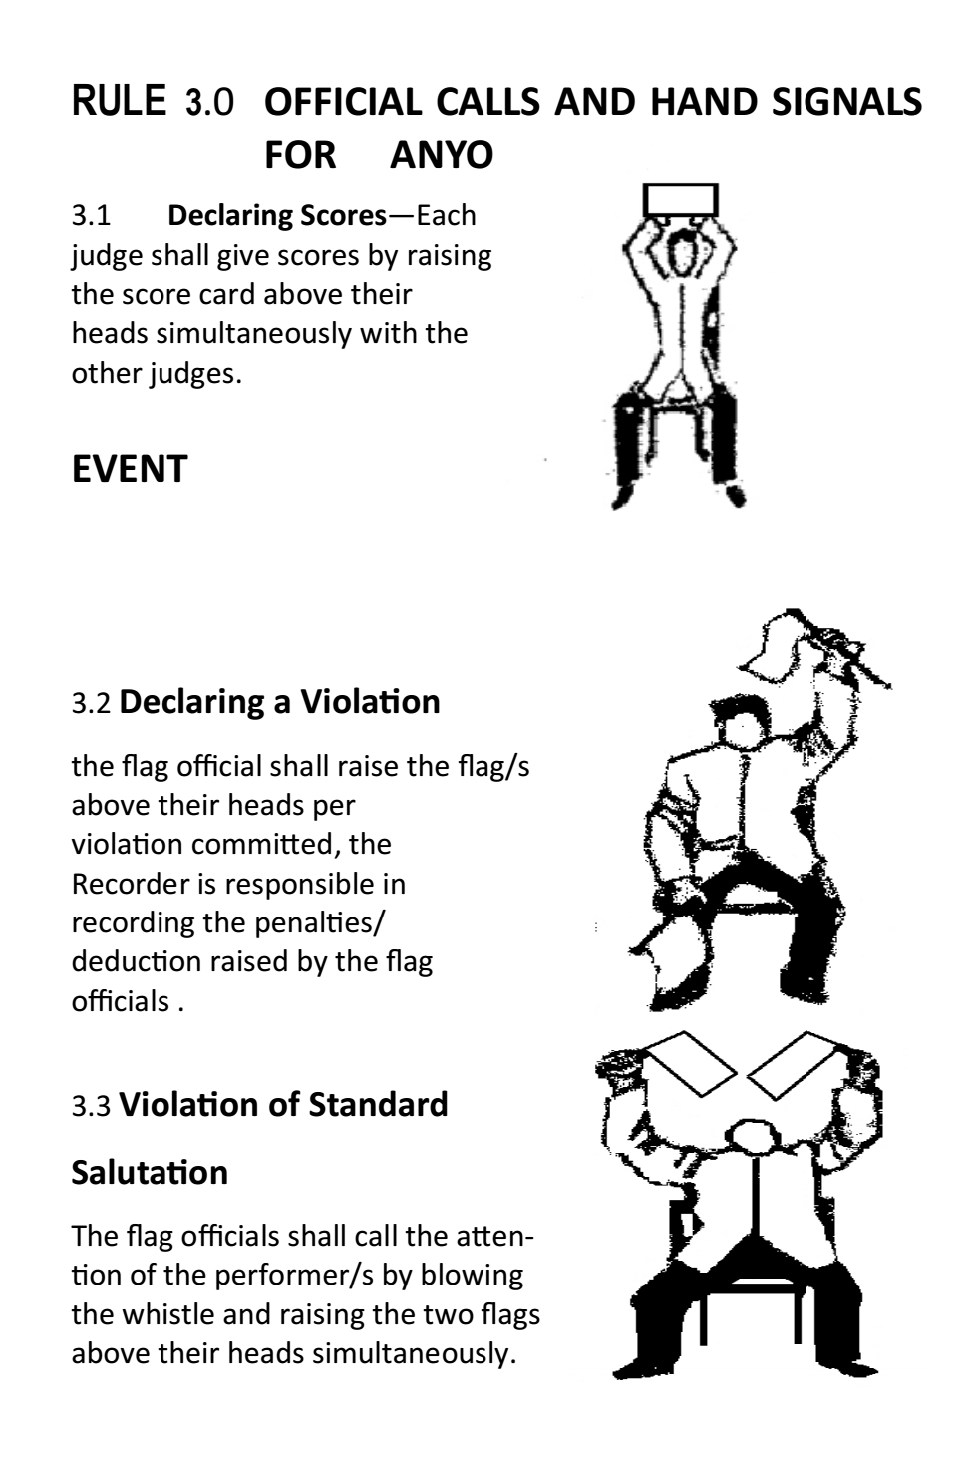
heads simultaneously.

3.1 Declaring Scores—Each judge shall give scores
by raising the score card above their heads simultaneously
with the other judges.

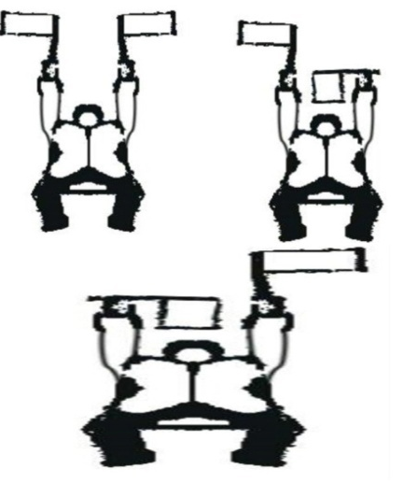
3.4 Declaring a knock out
Both flags raises, spontaneously horizontal above
the head for the knock out player

4.0 TIMER’S SIGNAL
The timer strikes the gong for the following signals:
a.) START - sound the alarm once.
b.) FINISH - sound the alarm prolong once.
c.) TIME-OUT - raise yellow flag on top of the table.
d.) CONTINUE - yellow flag is placed down.

OATH OF ALLEGIANCE

I, (full name), from (name of club and country), do hereby solemnly swear to abide by the principles and philosophies established by federation.

I pledge to follow the rules and regulations that bound my actions and reactions as a position (player/official). I shall remain respectful and considerate in whatever situation I shall be in.

I will practice Arnis as a means to bond with others to develop friendship and brotherhood.

I do swear also that I will not use Arnis as a means to hurt other people. I will remain a good citizen of my country.

So help me God!

